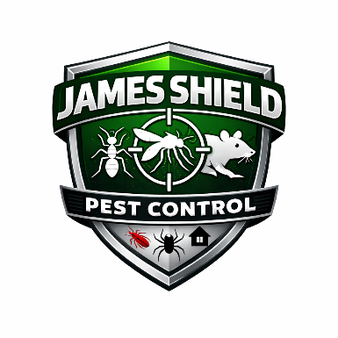
James Shield Pest Control
Attendance & Punctuality Policy

1. Purpose
Regular attendance and punctuality are essential to maintaining productivity, service quality, and operational efficiency.
Absenteeism and tardiness place an undue burden on coworkers and the Company.

2. Work Schedule Expectations
Employees are expected to:
- Report to work on time.
- Be ready to begin work at their scheduled start time.
- Complete their entire scheduled shift.
- Return promptly from meal and break periods.

3. Planned Time Off
All planned time off must be requested in writing and approved in advance, in accordance with the Company’s Vacation and Leave policies.

4. Unplanned Absences
If an employee is unexpectedly unable to report to work:
- The employee must directly notify their supervisor as early as possible and preferably before their scheduled start time.
- Leaving a voicemail message is not acceptable except in extreme emergencies.
- If voicemail is left due to circumstances, the employee must make a follow-up call later that day.
- If the supervisor is unavailable, reasonable efforts must be made to contact management.

5. Multi-Day Absences
Employees absent for more than one day must contact their supervisor on each day of absence unless otherwise instructed.
The Company may require a physician’s statement after:
- Three (3) consecutive days of absence; or
- Multiple absences related to illness or injury.

6. Absence During Workday
If illness or emergency occurs during work hours, employees must notify their supervisor as soon as possible before leaving.

7. Job Abandonment
Failure to notify a supervisor for three (3) consecutive scheduled workdays will be considered job abandonment and may result in termination.
The Company will review any extenuating circumstances prior to final removal from payroll.

8. Excessive Absenteeism or Tardiness
Undue or recurrent absenteeism and tardiness may result in disciplinary action, up to and including termination of employment.
The Company reserves the right to evaluate attendance patterns and address performance concerns as necessary.

9. Compliance with Leave Laws
This policy will be applied in compliance with:
- Paid Sick Leave laws
- FMLA
- ADA
- Workers’ Compensation
- Other applicable state or federal laws

10. Administration
James Shield Pest Control reserves the right to interpret and modify this policy as needed to ensure operational effectiveness and legal compliance.

